**Brooklyn torah gazette**

**For yom tov pesach 5779**

Volume 3, Issue ??? (Whole Number ????) 15-22 Nissan 5779/ April 20-27, 2019

**Printed L’illuy nishmas Nechama bas R’ Noach, a”h**

For a free subscription, please forward your request to [***keren18@juno.com***](mailto:keren18@juno.com)

**HISTORY**

**1,000 Years of Haggadahs [Part 3]**

**Rabbi Aubrey Hersh**

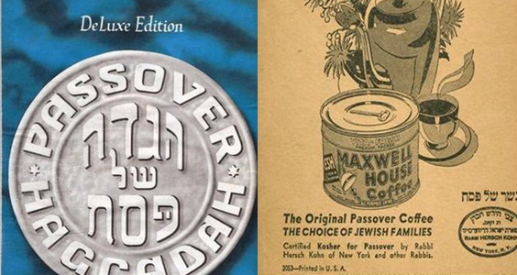

**20th Century Haggadahs**

For many American Jews, it is not an exaggeration to claim the Maxwell House Haggadah as the most commonly used and widely known. The story begins as a result of the immigration of Eastern European Ashkenazim into the USA, who were unused to drinking coffee and unsure whether the coffee bean was permissible during Pesach or whether it was kitniyos.

In 1932 Joseph Jacobs, an advertising genius in New York City, obtained a Pesach hechsher from Rabbi Hersch Kohn. General Foods and the Joseph Jacobs Advertising Agency, then approached Maxwell House and convinced them to give away a free haggadah with each purchase of a can of Maxwell House coffee.

Sales rose dramatically. It wasn’t the first time haggadas had been marketed—the State Bank of New York had done earlier giveaways—but it was the most successful by far.

More than 50 million copies of the Maxwell House Haggadah have been distributed over the years and it was famously used in the first White House Seder in 2009. Maxwell House stands in sharp contrast to one other mass-produced American Haggadah: the one given to more than 350,000 Jews serving in the United States military during World War II.

Its authors were not shy about making the link between the safe haven of America (the Goldene Medina) and the Promised Land of the Seder. It ends therefore, not at Chad Gadya, but with a trio of songs: Hatikvah, the Star-Spangled Banner, and America.

The first print run in 1943 carried an apt reminder about “generation after generation of Jews who have stood up to cruel taskmasters.” An equally poignant Haggadah was created in Gurs, in SouthWestern France.

Gurs was a Nazi internment camp for foreign born French Jews, which existed until 1942, at which time the majority of the prisoners were deported to Auschwitz via Drancy. Amazingly, in 1941 many of the Jews in the camp attended a seder, after Rav Shmuel Koppel managed to convince the authorities to allow Matza into the camp, and after one of the inmates produced a hand-written haggadah.

Rabbi Koppel described both the haggadah and Pesach itself in Gurs: “Before the Passover holiday, I brought an abbreviated version of the Haggadah, one that had been very well prepared by Aryeh Zuckerman. The Haggadah as written, with paintings by various painters incarcerated in the camp and short notes, all emphasized the concern of the imprisoned community… Thus, all the participants in the Seder could express their faith in the Rock of Israel while singing the traditional tunes of Echad Mi Yode’ah and Chad Gadya.

Rabbi Yehoshua Zuckerman, the son of the author of the Haggadah, related that his father who was born in Germany and emigrated to Belgium in 1924, was arrested in May 1940 and deported to France.

At Gurs he concerned himself with caring for the sick, education, organising religious life and Torah learning. His father told him how he had written the Haggadah from memory, and had apparently used a sharpened stone as a stylus to impress the stencils.

Another rather remarkable Haggadah was produced in Germany for Pesach of 1945, a month before the full Nazi surrender, by the advancing 42nd Infantry Division, known as the Rainbow Division. The Haggadah includes a letter from Eli Bohnen, a Jewish chaplain with the division, dated April 16, 1945.

‘’I am confident,’’ he wrote, ‘’that it is the first Hebrew religious work printed in Germany since the advent of Hitler.’’ The letter recounts that the Haggadah was printed on a captured offset press. “You may also be interested to learn that the soldiers who did the actual printing told us that when they had to clean the press before printing the Haggadah, the only rags available were some Nazi flags, which for once served a useful purpose.

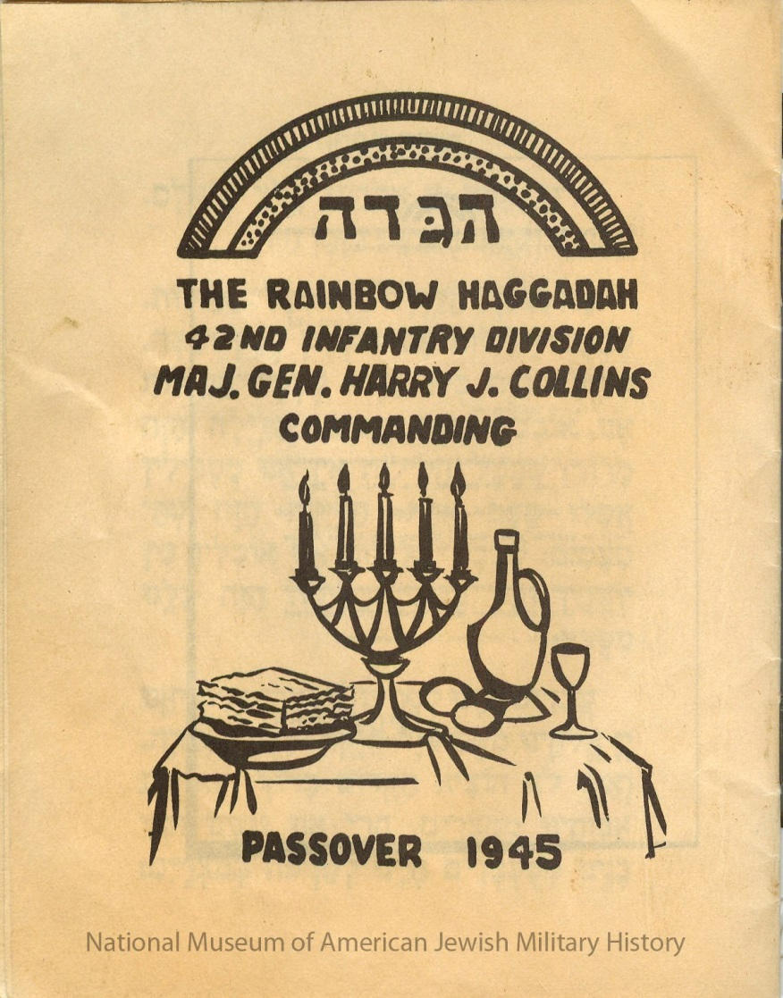

The Seder was attended by over 1500 soldiers. Since fresh eggs were essential to a Seder, we had to travel back into France to get 8 carts of eggs. Supervising the preparation for the Seder meal were GI cooks who had the local citizenry cleaning up.

Major General Collins came to express his good wishes.” Another unusual Haggadah was produced in Munich in 1946 for the DPs, who although no longer in bondage to Hitler, were not really free. They could not go home to their former lives, nor to Palestine as a result of the British blockade. And even America was closed to them.

How were they to ‘’celebrate’’ Passover? The opening page starkly rewrote the text’s most echoing words as: “We were slaves to Hitler in Germany…. And answered the question: What is the difference between this night and any other night, as being the absence of small children who traditionally asked the four questions.

The earliest candidate as a kiruv Haggadah in the 20th century was created not in Germany or the USA but in Cairo, Egypt. In 1917, Dr Hillel Farchi translated a Haggadah into Arabic. Despite other Arabic translations having appeared on the scene in earlier centuries, this one had two important differences. The language used was not Judaeo-Arabic but a more literary version, which was used by the more accultured and intelectual Jews, whom he was attempting to reach. And the Haggadah appears with copious notes. These are not simply a commentary on the Haggadah, they also cover history, archaeology and geography with the stated goal of proving that the biblical narrative is true.

Starting with the evidence of for Avraham and of civilisation in Ur Kasdim 4,000 years ago (see photo above), it includes maps, quotes and scientific data. Dr Farchi was born in Damascus in 1868 and after studying in yeshiva, earnt a degree in medicine and served as a doctor in Egypt for 27 years.

He was fluent in Arabic, Turkish, French, English and Italian and put his talents to use for the Jewish community. Closer to our day, the Unofficial Hogwarts Haggadah was launched in 2017 by Rabbi Moshe Rosenberg of Queens, New York, and was the top-selling book in Amazon’s Judaism category

*Reprinted from the Parashat Shemini 5778 email of ONEG SHABBOS – North West London’s Weekly Torah & Opinion Sheets.*

**The Lesson of Passover:**

**Anything Can Happen**

**By Rabbi Tuvia Bolton**

Here are a few Chassidic ideas and a story to enliven your Pesach Seder.

1) Pesach on one hand is the birthday of the Jewish people. On this day it was revealed to the world that we are the Sons of the Creator (Exodus 4:22) and free not only from Egypt but from the entire creation! But on the other hand, only a small percentage of Jews actually left Egypt (one Fifth!).

2) Although Pesach called the Holiday of Freedom (Zman Cherusenu) because we were freed from Egypt (sons of G-d), fifty days later at Sinai we became SERVANTS of G-d. (Lev.25:55): G-d made us responsible for the entire world. This is because freedom is worthless without responsibility.

3) It is a positive commandment on this night to talk of G-d's miracles in taking us from Egypt. The word Pesach can be divided into 'Pe' (mouth) Sach (speaks). Indeed, the power of the Jews is in their mouths; Saying words of Torah and praising G-d's miracles brings it both into to our hearts and out to the world. It helps us to remember who we are, feel how much HaShem loves us and gives us power to transform the present moment into the future redemption.

4) But on the other hand, the Haggada is very negative. It begins negatively (Before Abraham we were idolaters) and continues in detail to tell us how terrible the Egyptian slavery was. Even the name Pharaoh can be divided into 'Pe' (mouth) 'Ra' (evil). And he tricked us into backbreaking labor 'Perach' which can also be divided into 'Pe' (mouth) 'Rach' (soft talk).

5) Similarly, MATZAH, is called the food of faith and the food of healing. Simple and unleavened it represents an attitude of unquestioning, childlike, complete surrender to the Creator; open to the infinite. One of the biggest Mitzvas in Judaism is to eat Matza on Pesach. But it is almost identical to Chametz!

One of the biggest sins in the Torah is to eat Chametz or even to possess it on Passover. It is a commandment to get rid of it six hours before the holiday starts and the custom is to begin to search and destroy it the previous evening.

But both have the same ingredients; flour and water. And both are spelled almost identically. Both MaTZah and chaMeTZ have Mem and Tzadik. The difference is that 'Chametz' is spelled with the letter 'Chet' and Matzah has a 'Hey'. But Chet and Hey are also almost identical, the difference is that 'Hey' has a little opening at the top.

So, the only difference between unholy Chametz and holy Matza is a little hole. But that little hole has big ramifications. Chametz closed at the top, represents total disinterest in what's above while Matza is the opposite: total surrender to the Creator.

That's why Matza is 'low' and unleavened; because it gives us the feeling of how small we are and, simultaneously, we can connect to the Almighty and do the impossible.

6) MOROR is bitter and its letters (MROR) are the numerical value of Death (446). Paradoxically it is also connected with G-d's mercy [because it is put in the middle of the items on the Seder plate and according to Kabala mercy is in the 'middle' of the Ten Sferot].

Eating it reminds us of the bitter-as-death exile we are in and the even more-bitter fact that we don't really want to leave it. This will bring us to plead to G-d for mercy: that we should desire the redemption.

7) The four cups represent the four words for redemption used in the Torah (Exodus 6:6,7). Each cup of wine is another step in bringing out the redemption of the secret Jewish Soul in each of us [The letters of Wine (YYN) are the numerical value of 'Secret' (70)] and reveal our power to bring Moshiach and redeem the entire world.

Just like the wine is hidden in the grapes and must be squeezed out so too this two-thousand-year exile is only to bring out the hidden G-dliness in each of us and, consequently, in the entire world as well.

8) And just as wine brings joy, so too, the only way we can bring our Jewish souls into action and manifest the redemption is through Joy.

9) Finally, remember that when we open the door for Eliyahu, HaShem opens all the doors in heaven to our prayers; that is the time to REALLY request Moshiach NOW!!

To help feel all the above here is a story:

Some fifteen years ago over fifteen years after the fall of the iron curtain, a young Chabad Chassid was invited by a Chabad house in Russia to make a Passover "Seder" in a nearby town.

The young man, recently ordained as a Rabbi, arrived several weeks before the holiday. He went, together with the Chabad representative that invited him, to the Mayor of that town to look for a suitable place to hold the festive ceremony. They were expecting several hundred people and needed a big hall.

After a few minutes the Mayor decided that the only place in his town that would serve their purposes was the Communist meeting hall. It seems that when the Communists were in power, they made sure that the biggest building in every town in Russia would be their party meeting hall. The Rabbis and the Mayor went and had a look, and sure enough the place was perfect.

Posters were put up, people were invited personally, and food was brought and prepared. All the vessels had to be new, all the meat had to be strictly Kosher, the cooking had to be supervised constantly so that no one would bring "Chametz (leavened bread products) into the kitchen, and the building had to be completely cleaned, "koshered" and decorated.

All the work paid off. Some three hundred people arrived! Young and old, men and women, all dressed in their nicest clothes and with shining faces. Some came from nostalgia, some from curiosity, some for a good time. But everyone, whether they knew it or not, came because they were Jews and tonight was Passover.

It took a while to get everyone seated and settled. The Rabbi, through his translator, made a short welcoming speech telling them what to expect. For some of them it was their first "Seder" in fifty years, and for many the first in their lives. Hagaddas (Seder books) translated into Russian were handed out, cups were filled with wine, Matzot were distributed, and the evening began.

Everyone did what they were told with joy and listened to the Rabbi's explanations with great interest. They all read aloud from their books about how G-d did great miracles thousands of years ago, and how He took the Jews out of Egypt. They all ate the Matza, drank four cups of wine, finished their holiday meal, sang, and even danced at the proper times.

Everything went smoothly until the cup of Elijah. This symbolic "extra" fifth cup of wine is poured at the end of the meal to remind us of the imminent total redemption (G'ula Shlema). The young Chabad Rabbi explained with enthusiasm how this fifth cup stood for Moshiach who will arrive any moment to gather all the Jews to Israel and make a beautiful new world with the revelation of G-d everywhere etc.

Suddenly one of the older men stood up, tapped on the table and said in a booming voice, "Young man! Excuse me please young Rabbi!"

The place went silent and just as they all had listened to the Rabbi they now turned to the new speaker. He waited a few seconds and continued.

"We are very grateful to you for this beautiful evening with the wonderful food and wine.

Everything is very nice. Very beautiful and very tasty." Everyone in the room turned to one another, shook their heads in agreement and wondered what he was getting at.

"Everything you said is also very interesting and nice." The man continued. "Beautiful stories; G-d took the Jews from Egypt, made miracles...very nice Bible stories. We all love stories.

But what you said about some Messiah coming and making a utopia, building a Holy Temple and all this. Please Rabbi, we are grown up people. Some of us are academics, doctors, professors, intellectuals. We are not little children that we believe such nonsense! You are a very nice man and we are very grateful, but please save such foolish superstitions for your children not for intelligent adults. Please understand us, dear Rabbi, nothing personal but you are a naive person. You have been locked up in Yeshiva (Rabbinical College) and we live in the real world"

Everyone again shook their heads in agreement. And looked sheepishly at the Rabbi as though to say "We are sorry, but he's right."

The young rabbi however did not lose his composure. He waited a few minutes and before the man sat down he replied.

"My friend" he said with a warm smile, "My friends!" he opened his arms and looked around the room.

"Do you realize where we are? Do you realize what we are doing? Do you realize what you are saying!?

If someone would have told you twenty years ago that you would make a Passover SEDER in the COMMUNIST MEETING HALL, would you believe them?

Why, twenty years ago there was nothing more powerful and secure than Communism, and nothing weaker than Judaism! Communism was the complete opposite and biggest enemy of G-d and everyone in Russia was sure that Communism was right.

But here we are! The impossible has happened! Communism has not only fallen; this buildingâ€¦ the communist CENTER has been transformed to Judaism! So, is it really so far-fetched that Moshiach can change the entire world?"

The man looked at the crowd then back at the young rabbi, straightened up, smiled broadly and said..."BRAVO!!". And the entire crowd broke into applause.

May this story repeat itself with the entire world and all the potential blessings, optimism and holiness be revealed to change everything around us so we all dance in the true, final, complete redemption with...Moshiach NOW!!!

*Reprinted from the March 29, 2019 email of Yeshiva Ohr Tmimim in Kfar Chabad, Israel.*

**Prepping for Passover from Anchorage to Zanzibar**

**By Karen Schwartz**

***Chabad delivers millions of shmurah matzahs; will host thousands of Seders worldwide***

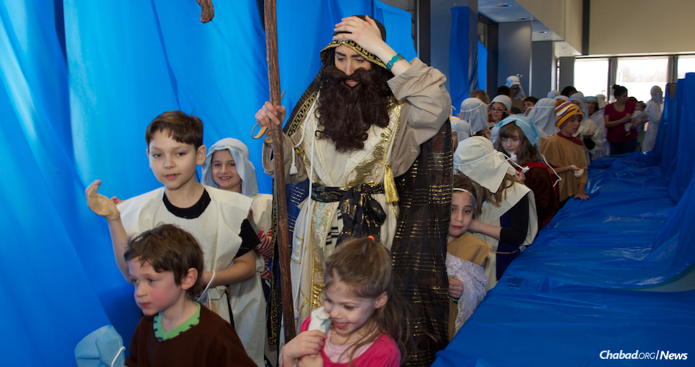

**Children in Anchorage, Alaska, re-enact the crossing of the Red Sea following the Exodus from Egypt. (Photo: Lisa J. Seifert)**

With [Passover](https://www.chabad.org/holidays/passover/default_cdo/jewish/Passover.htm) less than a week away, Rabbi Yossi Grossbaum was on the road Tuesday evening, delivering *[shmurah](https://www.chabad.org/holidays/passover/pesach_cdo/aid/1682/jewish/The-Difference-Between-Shmurah-Matzah-and-Regular-Matzah.htm" \o "The Difference Between Shmurah Matzah and Regular Matzah)* [matzah](https://www.chabad.org/holidays/passover/pesach_cdo/aid/1682/jewish/The-Difference-Between-Shmurah-Matzah-and-Regular-Matzah.htm) to people in his community. Grossbaum, who with his wife, Goldie, co-directs the Chabad Jewish Community Center serving Folsom, El Dorado Hills and the surrounding region in California, will spend some 50 hours getting the round, handmade matzah to area residents before the holiday begins this Friday night, March 30.

The Chabad center’s preparation for the eight-day festival (seven days in Israel), which commemorates the emancipation of the Israelites from slavery in ancient Egypt, started even before Purim. They placed orders for *shmurah* matzah, which the Rebbe—Rabbi Menachem M. Schneerson, of righteous memory—had long encouraged. The round, handmade matzah, which was watched to make sure the flour used to make it did not come into any contact with water or moisture, also serves as a way to raise awareness about the upcoming holiday, says Grossbaum.

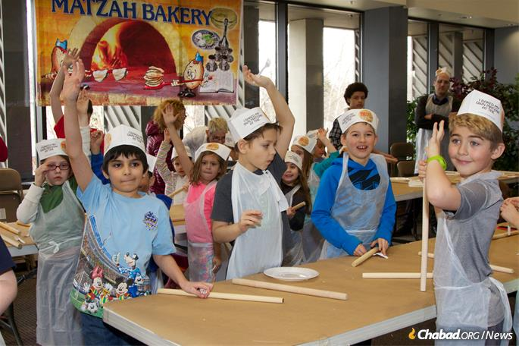

The Alaska program includes matzah-baking. (Photo: Lisa J. Seifert)

He and a group of volunteers will deliver some 100 to 150 boxes of the matzah for people to use at their Seders as they join Jews near and far in drinking four cups of wine, eating matzah and bitter herbs, and retelling the story of the Exodus on Friday and Saturday nights (Friday night in Israel). The Grossbaums, like Chabad-Lubavitch emissaries around the globe, will be welcoming guests to community Seders, theirs in Folsom and also in Placerville, some 25 miles away.

Thousands of such Seders will be taking place in hundreds of cities around the globe. In the U.S. Virgin Islands, emissaries Rabbi Asher and Henya Federman of Chabad-Lubavitch of the U.S. Virgin Islands will host some 100 Jewish local residents, as well as private and government contractors, on the island for the relief and rebuilding effort following hurricanes that raged through the islands in September, for the first night’s Seder. Meanwhile, Rabbi Yosef and Chani Konikov of Chabad-Lubavitch of South Orlando are getting ready to run Seders simultaneously in Hebrew and English for hundreds of visitors who head to the central Florida city for its warm weather and theme parks over the Passover holiday.

In rural Australia, Chabad of Rural and Regional Australia, will bring rabbinical couples and students to hold Seders in 11 locations, for nearly 1,000 Jews in remote cities. Chabad of Central Africa will be hosting seders in 20 locations from Zambia to Zanzibar. And in Russia, Chabad-Lubavitch will hold nearly 400 Seders in more than 200 communities.



**Cleaning for Passover looks the same just about everywhere,**

**including here in Chiang Mai, Thailand.**

Meanwhile, some 4,500 attendees are expected to converge for Seders in Bangkok, Thailand, and another 2,000 in other locations around the country. Additionally, in Kathmandu, Nepal, Rabbi Chezki and Chani Lifshitz are preparing for what’s considered [the largest Seder in the world,](https://www.chabad.org/news/article_cdo/aid/3980839/jewish/30-Years-in-Kathmandu-How-Worlds-Largest-Seder-Transformed-Jewish-Life-in-Asia.htm) which draws close to 2,000 travelers, many Israeli backpackers, in Kathmandu each year.

**Chabad of Central Africa will host 20 Seders.**

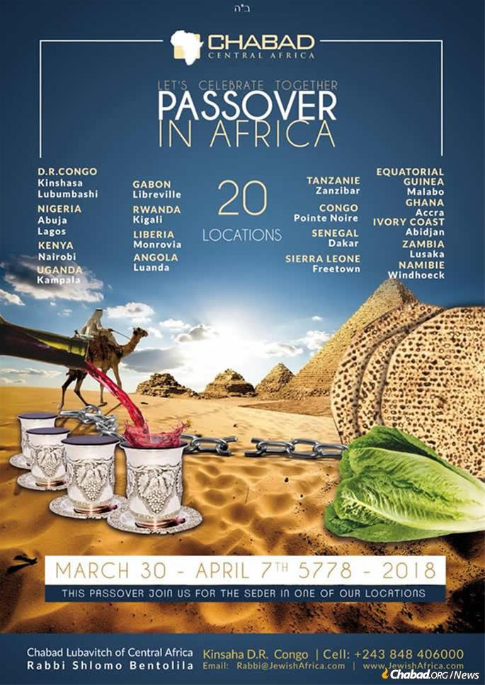

**Preparing for the Holiday**

All over the world, Chabad-Lubvitch emissaries will be helping people this holiday season with the many pre-Passover activities, including [distributing millions of](https://www.chabad.org/news/article_cdo/aid/3617369/jewish/1-Million-Pounds-of-Shmurah-Matzah-How-Passover-Production-Continues-to-Rise.htm) *[shmurah matzah](https://www.chabad.org/news/article_cdo/aid/3617369/jewish/1-Million-Pounds-of-Shmurah-Matzah-How-Passover-Production-Continues-to-Rise.htm)*and holiday guides in 17 different languages; cleaning for Passover; selling and burning *chametz*; and other preparations for the eight-day holiday. More than a million people around the world will sell their *chametz* via their local Chabad rabbi, in person or via mail.



**Chabad hosts thousands of educational programs before Passover all over the globe. (Photo: Lisa J. Seifert)**

Online, Chabad.org offers a full range of inspiration, information and services leading up to the holiday on the [Chabad.org Passover mini-site](https://www.chabad.org/holidays/passover/default_cdo/aid/109747/jewish/Passover.htm). More than 80,000 people sold their chametz through Chabad.org in 2017, and website administrators say they are expecting even more to use the service this year.

The holiday is a time for gathering together, says Mushky Glitsenstein, youth director of the Lubavitch Jewish Center of Alaska in Anchorage. They’ll be hosting a model matzah bakery for elementary-school kids, parents and community members where participants will be able to make their own matzah, from grinding the wheat to making the dough and rolling it out.

They’ll also have a live, mega-sized seder and interactive game show competition with 3-foot by 3-foot Haggadahs and matzahs 4-feet long by 4-feet wide ahead of the holiday. And they’re running a Passover experience program that lets kids bake their own matzah, shred their own *maror* (bitter herbs) and make their own *charoset*(paste of fruit and nuts). It’s a way to help engage kids and make Passover memories that will stick with them the rest of their lives, says Glitsenstein.

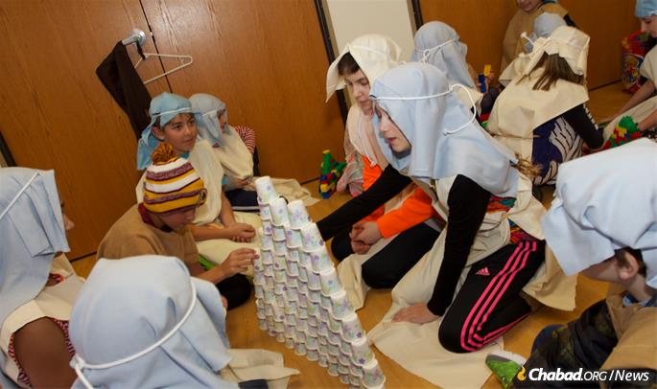

**Children in Anchorage learn to be part of the Passover story. (Photo: Lisa J. Seifert)**

“The goal is really for people to connect to the holidays, to identify with the story of Passover to make it relevant, to make it interesting, fun and something they want to be a part of,” says Glitsenstein. “When people experience the joy of Judaism, that’s when they want to bring it into their lives and make it something that’s lasting.”

The Chabad center, which flies in all of its Passover food from Seattle, will host a community Seder on Friday, March 30, sharing the holiday many feel a deep connection with, explains Glitsenstein.

“There is something about Passover that wakes up a Jewish soul,” she says. “Jewish people, no matter who or where they are, want to be at a Passover Seder. They want to celebrate it.”

*Reprinted from the Pesach 5778 website of Chabad.Org*

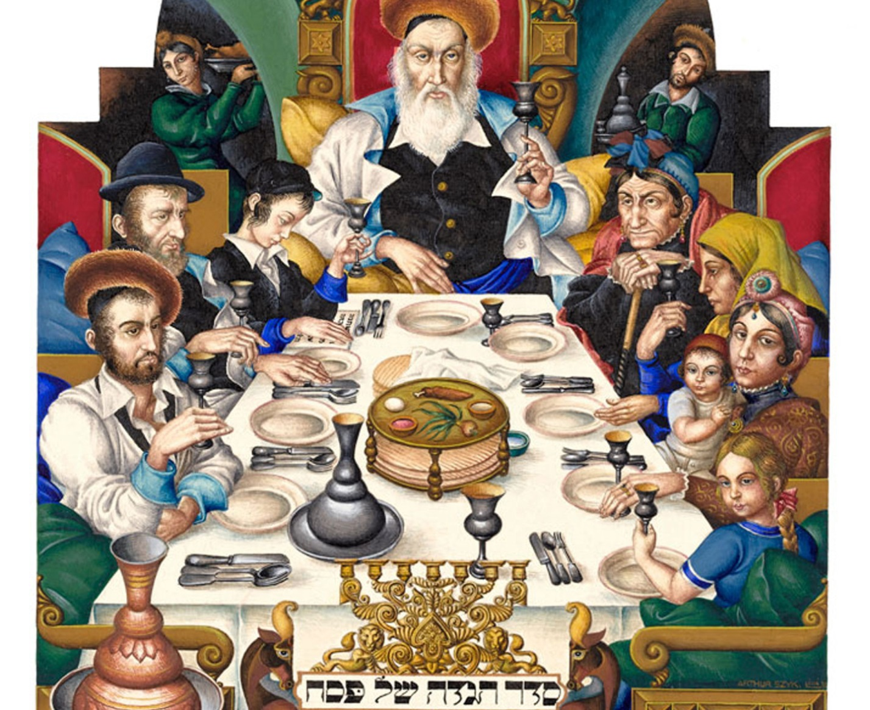

**A page from the classic 1940 Haggadah made by Polish artist Arthur Szyk.**

**Rabbi Berel Wein on Pesach**

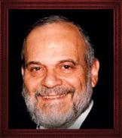

One of the more amazing things about the holiday of Pesach is that even though it is over 3300 years old it is relevant and current to our world today just as it was when it was originally celebrated by the Jewish people in Egypt long ago. It naturally speaks to every generation in a different tone and nuance, but its basic message of human freedom and Godly service has never changed.

Its rituals and commandments are the key to its longevity and survival over all the centuries and, in spite of all of the challenges and difficulties that are so replete in Jewish history. In fact, were it not for these rituals and commandments the holiday itself, if not even the Jewish people, would have long ago disappeared into the ash heap of history.

The G-dly instinct that has made ritual a daily part of the life of every Jew has been the surest method of Jewish survival and continuity. It is what binds the generations one to another in families and nationally. Without it, the disconnect between generations and the circumstances of society would be so great that it would be impossible to overcome.

The night of the Pesach Seder is the greatest example of the power of ritual and tradition to preserve human relationships and to bind disparate generations together. It is no exaggeration to say that the Jewish world is founded on the night of the Pesach Seder. Without it, we are doomed to extinction. With it, we become immortal and eternal.

I myself have always been privileged to celebrate Pesach and the Seder at home. I only went to a hotel for Pesach once in my lifetime when my wife was ill, and we had no other choice. I am not here to decry all of the Pesach programs that exist and prosper worldwide. I understand and appreciate why they are so popular and in our generation of relative affluence in the Jewish world, it is completely rational to use these services.

But it is completely ironic that in our time, because of technological advances, all sorts of automatic appliances, Pesach kitchens and an unbelievable plethora of prepared Pesach foods and products, that giving one’s family the unforgettable experience of a Pesach at home is slowly disappearing from the Jewish scene in many parts of the world.

Let me hasten to say again that I do not criticize anyone for any reason who celebrates Pesach at a hotel or with any sort of organized program. There are many circumstances in life that justify these choices. However, for the purposes of Jewish continuity and survival, I feel that it is important for children to remember a family Pesach at home, to recall how their parents and grandparents conducted a Seder and to be able to give personal expression to the glory of the holiday and to the memory of our history.

At the Pesach Seder there is a potential for uniting hundreds of years of family memories. Grandparents remember their grandparents and the little great-grandchildren, whose sole interest is to extort their elders for the return of the afikomen, are united in binding together hundreds of years of family life and Judaism. A Seder at home with the family provides the optimum setting for such an emotional and spiritual experience.

Eighty years ago, I attended the first Seder that I can recall. It was in the house of my grandfather who was educated in the great yeshiva of Volozhin and who was a rabbi of a congregation in Chicago as well as being one of the heads of the yeshiva that then existed in Chicago. That Seder is one of my earliest memories in life. I remember the deference that my father and uncles paid my grandfather and I recall how my cousin and I hesitatingly recited the four questions to him and the delight that shown on his face when we did so.

There were about 30 people at my grandfather’s Seder that year. Only my cousin and I still survive but I have tried to pass on the memory of that Seder to my own grandchildren and now great-grandchildren. By so doing, a whiff of Volozhin, and even of Egypt and Sinai, may be transmitted to them and from them to their generations as well. Like all else in Judaism, Pesach is memory. And memory is the most powerful tool for the preservation of a Jewish way of life.

I wish you and your families a happy and kosher Pesach.

*Reprinted from the Pesach 5778 website of Rabbiwein.com*

**Jewish History**

**Has the Exodus from Egypt Been Verified by Egyptian Archaeology?**

***Not many people know that the Israelites are clearly mentioned in ancient Egypt more than 3200 years ago. Perhaps it is hard to believe; Pharaoh lied about what actually took place***



**Question:** I learn with a non-religious young man who is interested in [Judaism](https://www.hidabroot.com/magazine/section/46979). We were discussing the mitzvah to remember what happened in Egypt and he said he would like to hear what Egypt says about what happened. He wants to hear their perspective, from historical writings, etc. I don't know where to find such information. Could you help me?

**Answer: To the Questioner**,

Papyrus Eifor describes massive reversals of nature in Egypt, dying in every house, a pillar of fire, and even tells that all the river has turned into blood (but in his mind it happened because of bodies in the water).

Also found in Egypt is the tomb of Merneptah, which is explicitly mentions the Nation of Israel more than 3,000 years ago.

Although the Egyptians wrote many papyri and documented history, unlike what many believe, they were not very truthful in their documentation, and did not record events that did not compliment them and their kings. The Egyptians obsessively covered up defeats and failures, to the extent that they did not document at all the 500 years of the rule of the Hyksos.

Hyksos was a Semitic group that invaded and ruled Egypt for 500 years until the Egyptians took over their kingdom. But despite 500 years of Hyksos history in Egypt - monarchy, construction, politics, government, laws and religions - the Egyptians did not record the history of the Hyksos who controlled them, thereby obliterating Egyptian history of 500 years.

All the remains that were found from the Hyksos rule are indirect finds (such as structures, pottery vessels, etc.), but not direct or hieroglyphic documents on this great chapter in the history of ancient Egypt. The only place in Egypt where the Hyksos are mentioned is almost incidentally - in the tomb of the sons of Hassan.

I cannot tell you whether the Egyptians destroyed evidence, but what is clear is that they did not want to document events of defeat and failure, not even if it be major and important events of 500 years. Let alone expecting that they would record the fact that their own slaves managed to humiliate and defeat them by means of divine signs and wonders.

But few know that the Israelites are clearly mentioned in ancient Egypt more than 3200 years ago. And perhaps it is hard to believe: But Pharaoh lied about what actually took place!

This is one of the most amazing finds from ancient Egypt, a famous tombstone called "the tombstone of Israel," in which Pharaoh Merneptah recounts how he made journeys in the land of Canaan, defeated various peoples, and finally destroyed the Israelites to the last of them! Thus he wrote: "Israel was destroyed - there is no seed for him." (Is it really surprising that the first external source in which the Children of Israel are mentioned is the description of their destruction?).

Well, the tombstone proves that the Israelites were known in ancient Egypt over 3200 years ago, and that they had already settled in the land of Canaan. But why did Pharaoh, the ruler of the mighty Egyptian empire, see it fit to lie saying he persecuted the Children of Israel in the land of Canaan and destroyed them to the last of them? Moreover, Pharaoh did not claim that he had destroyed any other of the nations.

In regard to other nations, Pharaoh only told that he had defeated them and pillaged them, yet only in regard to the people of Israel, did he declare with great enthusiasm that he did not leave even one of them...! For this reason it seems that Pharaoh had a very strong personal agenda in regard to the Israelites: he had acquired a great hatred for them and wanted to claim to the world that he had destroyed specifically their nation completely. It is interesting to note that in terms of the lineage, Pharaoh Merneptah was the son of Ramses II of the era of enslavement to Egypt. In other words, the son who wanted to protect his father's honor ...

The very fact that Pharaoh establishes a tombstone full of lies about his great victories, and lied about the extinction of the Israelites, shows once again that there is no reason to trust the integrity of Egyptian documentation. Moreover, the exaggerated boast of the annihilation of all of Israel implies that the Egyptians erased any evidence of the Israelites who might have degraded them (or rather, they simply did not record it).

In any event, with or without such evidence, one must know that archeology lacks much knowledge, and it is impossible to bring evidence from it *against* an event. The Egyptian dynasty is extinct, so it has no continuous history. Moreover, there are almost no archaeological finds from the Early Bronze Age. The lineage of Egypt is based largely on the writings of an Egyptian historian named Manatoun who lived about 2000 years ago.

Did you know that in all the inscriptions and hieroglyphics found in ancient Egypt, there is not even one mention of building pyramids in Egypt? Inside the pyramids there are no hieroglyphs and inscriptions at all. Archaeologists have many speculations about building pyramids, but ancient Egypt does not provide information about this connection. From this you can understand that the information about ancient Egypt and other cultures is deficient, and is based on scholarly hypotheses - more often than upon real facts.

With Blessings,

Hidabroot

*Reprinted from the March 28, 2018 email of Hidabroot.com*

**HISTORY [Part 1]**

**1,000 Years of Haggadahs Creating the Text**

**By Rabbi Aubrey Hersh**

The Mitzva to convey the story of Yetzias Mitzrayim is mentioned explicitly in the Torah, as are many of the pesukim associated with this experience. Yet certain elements of the Seder were only defined over the course of many centuries.

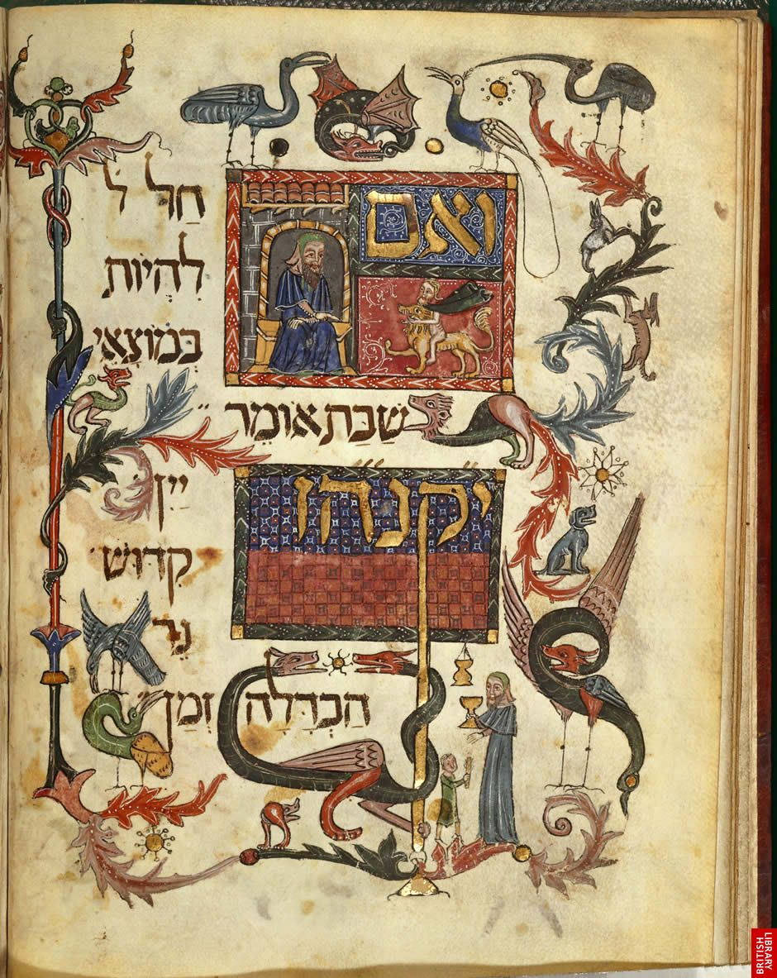

**Illustration of the famed Barcelona Haggadah**

The Tanna’im and early Amoraim created many of the familiar stages, including the central focus of the 4 cups of wine. However some well-known features such as Dayeinu, the story of Rabbi Akiva in Bnei Brak and the Four Sons, were introduced during the tekufos of the Geonim and Rishonim.

Even at that stage though, Nirtzah was still absent; indeed both the Shulchan Aruch and the Rama end the prescribed Seder immediately after the 4th cup of wine. Nevertheless we do find traces of Nirtzah within the Rishonim.

The Maharil (1360- 1427) mentions פסח סידור חסל - a paragraph originally said only as part of the Yotzros of Shabbos HaGadol – whereas נאה לו כי is to be found in the sefer Etz Chayim, which was written in pre-expulsion England in 1287.

The piyut הוא אדיר was composed, to be recited on Yomtov, although not necessarily on Pesach, as was the case for both Chad Gadya and Echad Mi Yodeah. All of these were subsequently adopted into the Seder by the Ashkenazim, however most Sefardi communities do not have any formal version of Nirtzah to this day.

Yet the importance of these additions can be seen from a teshuva of the Chida (whose Haggadah has no Nirtza at all) in חיים ת“שו שאל . He was responding to a query about someone who had publicly mocked the reciting of Chad Gadya and had therefore been placed into Cherem, which was now being challenged. Chida replies that the piyut originates from the mekubalim of Ashkenaz, and therefore טובא פשיטא נידוי דחייב – it is obvious that he should be ostracised.

**Earliest copies of Haggadah**

The oldest extant copies are to be found in the Geniza collection. They include a 9th century excerpt of the Rav Amram Gaon Siddur, and a 10th century complete Haggadah based on Rav Sadiah Gaon. A more unusual piece from the Geniza features the beginning of the Seder, but contains five rather than four questions. The extra question relates to being permitted only roasted meat on this night, and is formulated in the past tense:

“When the Beis Hamikdash stood, we used to eat only roasted meat”, which was how the original four questions are stated in the Mishna in Pesachim. It was removed from most Haggadahs after the Churban.

This excerpt also has a change to the standard order of Mah Nishtanah by first asking about the dipping of food on Seder night and then subsequently the question regarding chometz and matza. It was written in three languages. On the right hand column we find the concluding part of Havdallah in Hebrew, although the nussach includes sections that we do not קדושים תהיו כי קדוש as such nowadays say by followed is This. אני, ואבדיל אתכם מן העמים instructions and halachos written in JudeoArabic (which uses Hebrew letters to write Arabic) and the brocho of Borei Nefashos to be said after Karpas - as opposed to our custom of eating less than a kzayis, so as to avoid the question of requiring this brocho.

The left hand column contains the Four/Five questions in Hebrew until the penultimate line of the fragment, where an Aramaic translation beginsלילא שנא מה) )הדין ,as some people would have been more familiar with Aramaic than Hebrew, at the time this hagaddah was composed in the 11th century.

Handwritten Illuminated Haggadahs The Haggadah first appeared as a separate book (rather than as part of the Siddur) in 1280, although the more famous illustrated ones would only be produced from 1300 onwards.

These would subsequently become known by a specific title which would relate to either the place of origin (Barcelona Haggadah, Darmstadt Haggadah), design (Golden Haggadah, Sister Haggadah), current location (Cincinnati Haggadah, Rylands Haggadah) or owner (Kaufman Haggadah, Mocatta Haggadah).

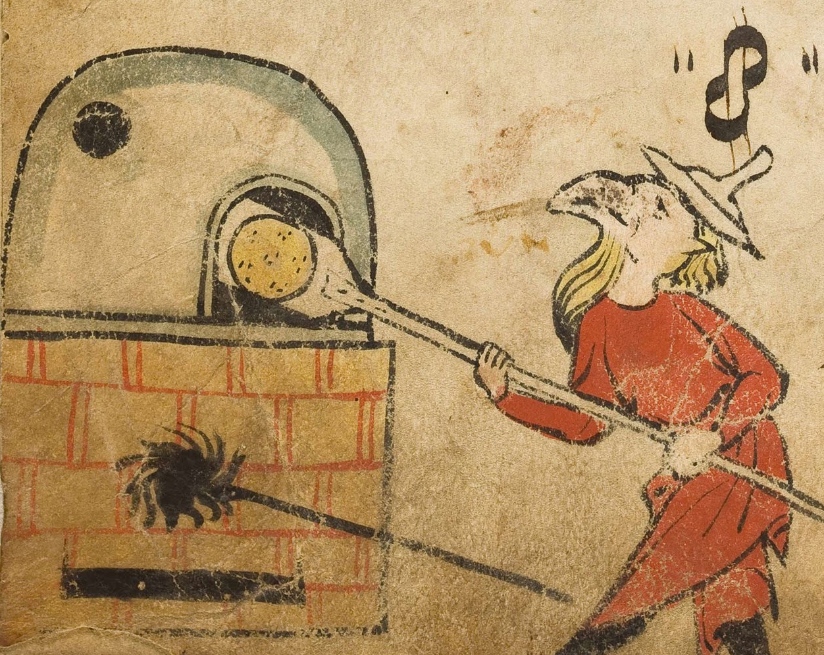

**Illustration from the Birds’ Head Haggadah**

The Birds’ Head Haggadah (c. 1320) is so named because this feature replaces human faces throughout. There is no consensus in academic circles as to the reason behind this, although some point to the prohibition of drawing the image of a human being. And whereas all adult Jewish males have a beard and a Jewish hat, children are bare headed, as is the image of Yosef as the ruler over Egypt. Interestingly, whilst the drawings of Jews have a bird’s head, the non-Jews are depicted with blank circles instead of faces. Hence in the scene of the Egyptians pursuing the Jews immediately after after Yetzias Mitzrayim, the former are all faceless, yet two figures do appear with birds’ heads.

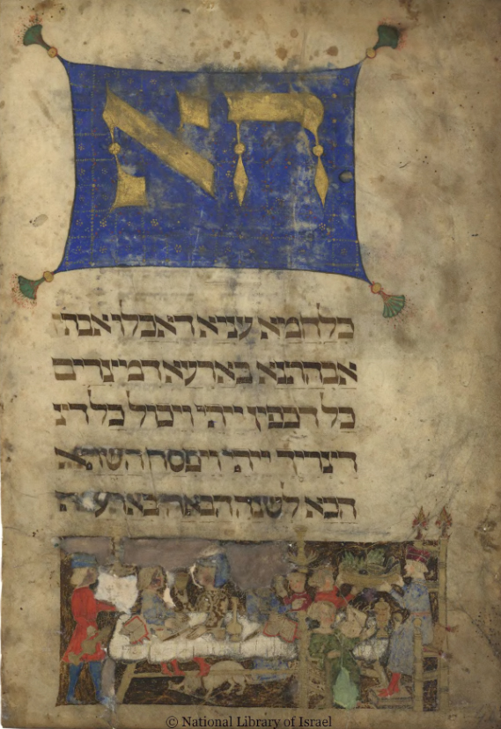

**Illustration from the Rothschild/ Murphy Haggadah (Italy, circa 1450)**

It has been suggested that these two are Dassan and Aviram, Indeed, they are brandishing whips indicative of their role as nogsim (Jewish taskmasters). The Haggadah was acquired by the Israel Museum for $600 in 1946, from a German Jewish refugee called Herbert Kahn. However in 2016, the heirs of the family that had owned the Haggadah prior to the war, asked for compensation, claiming the Haggadah had been sold on without permission. Their precise demand was not made public but was understood to be for a few million dollars (which is substantially less than the Haggadah’s actual value). In addition they asked for the manuscript to be renamed the “Marum Haggadah”.

The museum – which considers itself a caretaker of any heirless Judaica that was once owned by Holocaust victims - acknowledged the family’s ownership preWorld War II, but requested documentation for the period between 1933 and 1946. In response, the Marum family obtained more than 1,000 documents from Karlsruhe, which depict Kahn as a low-paid schoolteacher who was in constant need of cash.

The family claim that Kahn somehow obtained the Haggadah in 1939 after the Marum family patriarch was deported, although they do not believe it was stolen. More likely the book ended up in a Jewish school in Germany (where Kahn was teaching), to avoid it being confiscated by the Nazis.

One of the illustrated pages features Mattan Torah. Although two luchos were given at Har Sinai, since the Torah is made up of five books, the artist incorporated both these concepts by transforming the two into five.

A similar fate befell the “Rothschild/ Murphy Haggadah” (Italy c. 1450). Up until 1939 it belonged to Baron Rothschild. It was subsequently looted, and then sold to an American, by the name of F.T. Murphy, who bequeathed it to Yale University. In 1980 it was identified and returned to the Rothschild family.

One particular Haggadah was known as much for its controversy as for its art: the Washington Haggadah, which came into being two centuries before any Jews lived in the USA. Written by a scribe called Yoel ben Shimon, who completed it on the 25th Shevat 5238 [January 29th 1478], it was donated to the Library of Congress at the start of the 20th century, although as a handwritten comment in the margin makes clear, it was still in active use in Germany as late as 1879.

However in the text for Eruv Tavshilin, we find the scribe writing that the procedure permits one to cook on Yomtov for Shabbos and on Shabbos for Yomtov. The latter phrase is clearly mistaken (it is unclear with whom the mistake originated), and when facsimile editions were published in the USA in 1964 and sold publicly, Rabbonim were concerned that people might be misled.

The Agudas HaRabbonim therefore put advertisements in the Yiddish newspapers, to warn everyone of this erroneous statement. The Haggadah also contains a drawing of a man pointing to his wife, when he declares: “This bitter herb”!

This theme first appears in the Chilek & Bilek Haggadah – produced in the mid- 1400s and currently at the Bibliotheque Nationale in Paris - in which both spouses point at each other when the husband picks up the Marror, and a dialogue with ‘speech bubbles’, shows each spouse making the accusation that the other is the real bitter herb.

The Wicked son is portrayed as a Christian knight, wearing armour and holding a sword. This familiar image, which is the Western embodiment of chivalry, was for the Jews a symbol of crime and violence, and is very revealing about Christian and Jewish relationships in Ashkenaz.

*Reprinted from last year’s (5778/2018) email of Oneg Shabbos, North West London’s Weekly Torah & Opinion Sheets for Parshas Tzav/Shabbos Hagadol 5778. Rabbi Hersh is a Lecturer, Historian & European Tour Provide. The author can be contacted at aubrey@jle.org.uk*

**The Timeless Symbolism**

**Of the Seder Egg**

**By Rabbi Moshe Meir Weiss**

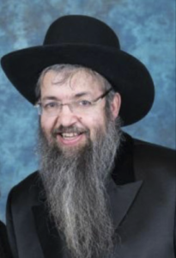

One of the ancient symbols at the Seder table is the egg and there is a plethora of reasons why we eat it on Pesach by night. An egg is symbolic of birth and beginnings, and is therefore a fitting reminder that the Jewish nation was born on Pesach, and that our history as a people began as we exited from Egypt.

Eggs also have the unique feature. The longer we cook them the harder they become. So too, says the Chasam Sofer, Zt”l, Zy”a, were the Jews: in Egypt, the more they persecuted us the more we increased, as the posuk says, “K’asher y’anu-u oso, kein yirbeh v’chein yifrotz – In direct proportion to the amount that they afflicted us, so did we multiply and so did we spread out.”

Also, the egg is the counterpart of the zeroah and reminds us of the two sacrifices we ate from on the night of Pesach, namely the korban Pesach and the korban Chagigah.

But, the egg is also the premier symbol of mourning. Firstly, because an egg is round and, as such, it represents the wheel of life that turns and reaches everyone, when ultimately the fate of death touches us all.

But, even more prominent is the fact that an egg is seamless. It has no openings and thus represents the mourner, for Chazal tell us, “Ovel ein lo peh – The mourner has no mouth.” He is speechless and dumbfounded by his loss and therefore the egg, which has no cracks, crevices, indentations, or niches, is a fitting symbol for the mourner who is silent in grief.

The reasons why we eat the food of mourning at our festive Seder table are also varied. One reason is because we are mourning the destruction of our Temple and thus our inability to enjoy the korban Pesach, the centerpiece of the ancient Seder. We also realize that every year, on the same night of the week in which the Seder falls, so too falls Tisha B’Av and therefore the egg brings to mind the destruction of our Beis HaMikdash. The egg is also a sad reminder of the passing of Avraham Avinu, whose yahrzeit is on the eve of Pesach.

But, there is another vital symbolism in the fact that the egg has no opening. The night of the Seder is the anniversary of Makos Bechoros, the Death of the Firstborn. Chazal tell us that, on that night, incredible devastation struck the people of Egypt. “Ein bais asher ein sham meis,” there was literally no house that was spared from death. If there wasn’t a firstborn in a particular Egyptian house, then the head of the household was struck down. Thus, in a very real sense, Egypt was silenced on this night. They were all in mourning. They were speechless and they had no mouth. The egg recalls this great miracle.

Why were the Egyptians punished in this devastating way? In Hallel we say, “B’tzeis Yisroel m’Mitzrayim, Beis Yaakov meam loez – When Yisroel left Egypt, the House of Yaakov from a land of a foreign tongue.” There is however, another definition of ‘meam loez.’ The word ‘laz’ also means slander and thus it can be rendered that Hashem took out the House of Yaakov from a nation that slandered us.

As we know the posuk tells us, and in the Haggadah we recite it, “Vayare-u osanu HaMitzrim – The Egyptians made us into evil people,” slandering us by saying that if an enemy would attack, we would traitorously join with the enemy and drive the Egyptians from their land.

Using this terrible slander, they turned their backs on the kindness of Yosef and instituted the final solution of drowning our babies and crushing our people with avodas perech, the incredibly cruel and sadistic backbreaking labor. It was for this campaign of slander that Hashem silenced all of their mouths with the grief of Makos Bechoros.

Unfortunately, we too were affected from the Egyptian environment and also succumbed to the sin of slander, as we find that Dasan and Aviram slandered Moshe Rabbeinu to Paroh, and Moshe Rabbeinu made the declaration “Achein nodah hadavar – Now I understand the matter.”

As Rashi explains, Moshe Rabbeinu declared, ‘Now I see why the Jews are suffering in Egypt. Because, they are guilty of the heinous crime of slander.’ It would only be later, after suffering through the torture of persecution that the Medrash states that we were then worthy to be redeemed, “Shelo hayu bahem daleitora – There were no more talebearers among us.”

It is interesting to note that the Hebrew word for silence is ‘sheket,’ made up of the letters shin-kuf-tes. Those letters also spell the Hebrew word ‘keshot,’ to adorn oneself, because Yiddishkeit recognizes the beauty of silence. When we have the self-control to hold back from talking about others, we beautify ourselves with the trait of refined speech.

It is scary to note what happened to Dasan and Aviram. As the Medrash reveals to us, for their slander against Moshe Rabbeinu, Hashem caused them to become impoverished by taking away their influence so that no one would take their word seriously. Unfortunately, they didn’t get the message and they continued in their sinful ways until they met a horrible end, dying with Korach and his cohorts.

This teaches us how dangerous it is to turn a deaf ear to Hashem’s warnings and signals. Rather, the smart person, when something chas v’sholom goes wrong, always asks himself, ‘What must I change and how can I mend my behavior?’

The Seder narrative is called Magid. Once again it is interesting to note that an anagram of the word ‘magid’ is ‘dagim,’ fish. Perhaps this is because fish have no speech. We, on the other hand, utilize our speech but only to relate Hashem’s praise.

The egg, therefore, the symbol of silence, is a terrific springboard at the Seder table to remind our children and our loved ones that we must avoid, at all costs, the ruination of talking about the flaws and weakness of others. This was the way of Egypt, which led to their doom. May it be the will of Hashem that we guard our tongues from speaking evil and, in that merit, may Hashem bless us with long life, good health, and everything wonderful.

*Reprinted from the Pesach 5778 email of The VUES.*

**Unusual Passover Cards**

**By** [**Saul Jay Singer**](http://www.jewishpress.com/author/saul-jay-singer/)

Regular readers of this column know that in my Jewish festival pieces, I often like to feature intriguing and historical greeting cards, which constitute a window into Jewish history in general and how Jews have historically celebrated their holy days in particular.

In this piece, however, I would like to showcase four of the more unusual Passover cards in my collection.

Exhibit 1 is a Yiddish card circa 1910, which shows a couple dressed in their finery appearing before a judge in a crowded American courtroom. The exchange on the card, a classic example of Yiddish vaudeville humor at its best, runs as follows:

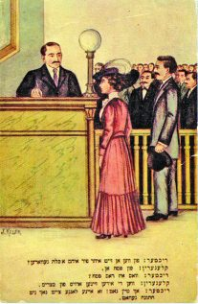

Judge: When were you married?

Parties: On Pessach

Judge: What is Pessach?

Parties: When the Jews left Egypt

Judge: Oh my G-d, that’s a long time to be married!

Not to step on an amusing punchline, but it is worth noting that the author of this card was apparently unaware that Jewish law prohibits marriages on Jewish holidays, including during the intermediate days of Passover. First, because “we do not mix one joyous occasion with another” (*Moed Katan*8b), which would detract from the pure joy of each occasion; second, because we do not enter into a legal transaction during holidays, including *Chol HaMoed*, and the wedding ceremony is considered a legal transaction.

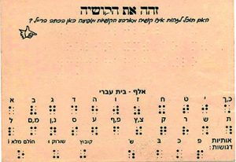

Exhibit 2 is a very unusual postcard written in Braille; can you determine which of the Four Questions is written on it? (The answer appears at the end of this column.)

An old gag, typical of old Borsht Belt humor: A blind man at a Seder inadvertently picks up a piece of matzah instead of his Braille Haggadah, runs his fingers over it, and asks “Who wrote this nonsense?”

The Jewish Braille Institute (now called “JBI International”), founded in 1931, compiled worldwide censuses of blind Jews; began a correspondence course program for blind Jewish youth; and maintained a circulating library of books related to Judaism and Jewish culture. (In 2003, JBI donated its entire 70,000 volume library to the Library of Congress.)

Today, it provides religious instruction to blind Jewish children and also published a free international Braille magazine of Jewish culture, to which Helen Keller wrote (1959): “With pride, I still read the Jewish Braille Review, which the Institute publishes for the blind, and bless the spirit of sympathy and brotherhood in which it serves both Jews and Christians in many lands.”

One of the first challenges faced by the Institute was the need for a uniform Hebrew Braille (which would be read from right to left!), so it mobilized an international panel, which formulated an International Hebrew Braille Code (1936) and which, after many adaptations, was completed in 1944. Mrs. Harry Cole, an early Hebrew Braille Code expert, took over five years to complete the first Braille translation of the Hebrew Bible.

It is difficult to pin down who created the first Braille Haggadah and when. Possibly the first such Haggadah, which was acquired by the National Library for its renowned collection of *haggadot*, was printed in the United States in the early 1950s in cooperation with the New York Guild for the Jewish Blind. In the mid-1950s, Temple Shalom in Succasunna, NJ produced what it claimed was the first Hebrew-English edition of the Haggadah, and Rhea Fink created a version in 1956.

Another claim to publishing the first Hebrew-English Braille Haggadah was made by the son of Bernice Wolfson of Beth El Congregation in Omaha, Nebraska, who tells a wonderful story: The renowned blind jazz pianist, George Shearing (famous for “Lullaby of Birdland”), was in town for Passover, and Bernice invited him to attend the family Seder, where he was thrilled to read from her Braille Haggadah.

The family was invited to attend his concert the following night, at which he announced, “Last night, I had an extraordinary Passover experience with the Wolfson family” and proceeded to play a jazz variation of *Dayeinu*.

Though there is a general decline in the use of Braille books due to technological advances using computer-assisted reading technology, Braille *haggadot* continue to be in demand to facilitate the full participation by the blind in the Passover experience.

Exhibit 3 is an April 10, 1908 advertising card mailed from Cleveland by the C. Cook & Co. that reads as follows:

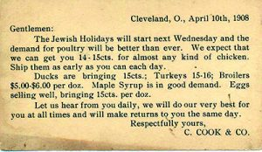

*The Jewish Holidays will start next Wednesday and the demand for poultry will be better than ever. We expect that we can get you 14-15 cts. for almost any kind of chicken. Ship them as early as you can each day.*

*Ducks are bringing 15cts.; Turkeys 15-16; Broilers $5.00 – $6.00 per doz. Maple syrup is in good demand. Eggs selling well, bringing in 15cts. per doz.*

*Let us hear from you daily, we will do our very best for you at all times and will make returns to you the same day.*

According to the Commodity Year Book, which used U.S. Department of Agriculture data, the average price of a dozen eggs in New York in 1908 was 22 cents. At first blush, one might think that the Cook Company was offering its customers a tremendous bargain but, in fact, the price of eggs in New York was much higher (a staggering 47 percent higher), which may be traced to 1906 when a group of New York City kosher poultry distributors organized the Live Poultry Commission Merchant’s Protection Association, which fixed wholesale prices for kosher poultry; forced poultry retailers to buy exclusively from the Association; and punished uncooperating retailers while setting up competing local retailers who sold their goods at significantly reduced prices.

Thirteen Association members were convicted of illegal price-fixing in 1911 based principally upon the testimony of Bernard Baff. As a result – aside from his livestock being poisoned and his store bombed – he was murdered by 100 poultry retailers who resented his cutting out middlemen and selling at prices significantly lower than the competition.

To lend a bit of perspective to these prices, however: One 1908 dollar is worth about $25.60 today. As such, kosher poultry for Passover would run the 1908 consumer about $3.58 to $3.84 at today’s prices (and a dozen eggs would also be about $3.84).

During the beginning of the 20th century, chickens were mostly raised on family farms, which sold eggs as their primarily income source; chicken meat was a delicacy reserved for holidays and special occasions – and the Passover Seder certainly ranked as both a holiday and “a special occasion” for Jews. Kosher poultry was more expensive than beef but, only a few decades after the Cook Company issued our Passover price list, industrialized farming and transportation made chicken widely available and much cheaper.

And that’s why, even today (and ever since Herbert Hoover’s 1929 presidential campaign), politicians always promise “a chicken in every pot” – albeit not necessarily a *kosher* chicken, which is still far more expensive.

Exhibit it 4 is an anti-Semitic card displaying a grinning “Jewish matzah,” complete with a caricature Jewish beard and hat, with the Yiddish caption: *Du Bist a Matze Ponem* (“You have a Matzah face”). Due in part to the increased immigration of European Jews to American shores at the turn of the century and the accompanying increase in anti-Semitism, it was issued in 1905 as part of a series mocking the Yiddish language and showing less-than-flattering depictions of Jews.



And now for the answer to the Pesach Braille quiz: The card features the first question of the *Ma Nishtanah*: “On all other nights, we eat chametz and matzah, but on this night only matzah.”

Wishing all a*chag kasher v’sameach*.

*Reprinted from the March 28, 2018 website of The Jewish Press.*

**A Hardened Heart**

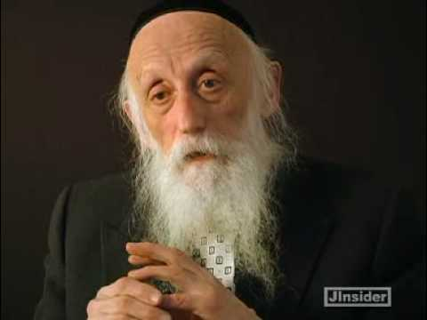

**Rabbi Dr. Abraham Twerski**

Later in the parasha, when Egypt was barely surviving the plagues inflicted on it by Hashem’s wrath, we read, “*But I shall harden Pharaoh’s heart and I shall multiply My signs and My wonders in the land of Egypt*” (7:3). Hashem is speaking after Pharaoh was stubbornly refused to let the Israelites leave Egypt to serve Hashem.

The famous question is asked by all the commentaries: “*How can Hashem harden Pharaoh’s heart, thereby removing his bechira (free will), and then punish him and his people with even more severe plagues?”*

The answer our Rabbis give is that Pharaoh was his own worst enemy. Hashem gives everyone a chance to choose how to utilize their own free will. We must not ignore the numerous opportunities that Hashem gives us to improve our ways. Nevertheless, Hashem can remove our free will at any time — as He did with Pharaoh, after he ignored Moshe’s request to let B’nei Yisrael go. If we choose to follow a path that leads us to sin and we continue on that path, then Hashem will make it harder for us to refrain from committing that sin.

In parashat Balak (22:35) the angel of Hashem says to Balaam, “*Go with the men, but do not say anything other than the exact words that I declare to you*.” Rashi comments: “*bederech she’adam rotze le’lech, ba molchin oto* — Along the road on which a person wishes to go, there he will be led!” In other words, the way that you really wish to go, that is the way you will allow yourself to be led. Hashem’s guidance proceeds from our own decisions. It is entirely in our hands, which path we want to take: One that will lead us to spiritual growth or *has veshalom*, to spiritual decline.

Rabbi Twersky relates how forty years of working with alcoholics enabled him to understand Pharaoh’s obstinacy. The alcoholic can suffer blow after blow, each time swearing off drinking: “*I will never drink another drop as long as I live*!” Invariably, the alcoholic resumes the drinking soon afterward.

The Rabbi remembers one man whose drinking resulted in severe pancreatitis, which caused such horrific pain that it was not relieved even by morphine. He cried bitterly, “*If you can only get me over this pain, Doc, I swear I will never, ever even look at alcohol*.” Three weeks after being released from the hospital, he was drunk once again. Alcoholics who go through the ordeal of a liver transplant may drink on their first visit outside the hospital.

Pharaoh acted like a typical alcoholic. When he felt the distress of a plague, he pleaded with Moshe (just as the patient pleaded with Dr. Twersky), promising to send out the Israelites. No sooner was the plague removed, when Pharaoh immediately retracted his words. Rabbi Twersky relates that this behavior is not at all unusual.

*Reprinted from the Va’era 5779 email of Rabbi Amram Sananes as written by Jack E. Rahmey.*

**The Shmuz on****Pesach**

**I’m Never Wrong**

**By Rabbi Bentzion Shafier**

**Founder of TheShmuz.com**



**Rabbi Bentzion Shafier (The Shmuz.com)**

“*Moshe said: “So said HASHEM, ‘At about midnight, I shall go out in the midst of Egypt.*” – Shemos 11:4

**Moshe Changed the Wording**

After months and months of HASHEM showing the Mitzrim that He alone controls every aspect of Creation, Moshe was instructed to warn Pharaoh that if he still wouldn’t let the Jewish people go, then exactly at the stroke of midnight, every firstborn in Mitzrayim would die. Yet when Moshe appeared in front of Pharaoh, he changed the message and said, “If Pharaoh doesn’t free the Jews, then approximately at midnight, every first born will die.”

Rashi is troubled by why Moshe would change HASHEM’s wording. He explains that Moshe was afraid that if he gave an exact time, the Mitzrim would be watching the clock and might miscalculate. Rather than assuming that they were wrong, they would attribute the error to Moshe and assume that he was a liar. To remove this potential pitfall, Moshe changed what HASHEM said and told Pharaoh that at around midnight, the firstborn would begin dying.

**How Did the Mitzrim Tell Time?**

This Rashi seems quite difficult to understand. In our times, we have precise instruments to measure time; we have clocks, watches, and chronographs. In the ancient world, timepieces were crude. During the day, a sundial might provide some degree of accuracy, give or take a few minutes.

But the makkah of b’choros was at night. The way the Mitzrim would tell time at night was by gazing at the stars. They would look up at the stars’ alignments and approximate the time. How accurate could this possibly be? The telescope had yet to be invented; sophisticated mathematics was yet to be discovered. So what right would they have to assume that they were right and Moshe was wrong?

**Ten Months of Being Proven right**

What makes this even more difficult to understand is that for close to a year, Moshe and Aaron appeared in Pharaoh’s palace, miraculously foretelling what would happen if Pharaoh didn’t allow the Jews out of Mitzrayim. Time after time, events occurred exactly as Moshe predicted. In the precise manner, in the specific time, and with startling exactness, what Moshe said would happen, did happen. So why would the Mitzrim assume that they were correct and Moshe was lying? Wasn’t it much more likely that they were the ones who made the error?

**I Am Never Wrong**

The answer to this question is based on human nature. We tend to assume that our opinions are correct, regardless of the evidence against us, and irrespective of whom we might be arguing with. While we may not have given much thought to how we arrived at our understanding, once something becomes accepted as our opinion, it becomes very difficult to change.

We are heedless in the forming of our opinions

Moshe was afraid the Mitzrim would calculate the time, and despite the questionable accuracy of their calculations, they would jump to the conclusion that Moshe was wrong – that he was, in fact, a liar who fabricated the entire situation. To prevent this Moshe said, “around midnight.”

The implications of this concept are far-reaching when we take them to their logical conclusion. Let’s assume for a minute that Moshe hadn’t changed the expression. Let’s assume he said that exactly at midnight HASHEM would kill the first born. Moshe was afraid that when the makkah began, the Mitzrim would miscalculate the time and conclude that it began at exactly 11:45 PM.

What would that prove? If Moshe was off by a few minutes, therefore what? Everything else he said till then was true. But even more, every firstborn would miraculously have died, exactly as Moshe said they would. What possible conclusion could the Mitzrim reach that would make it worthwhile for Moshe to change the words that HASHEM said to him?

Here again, we see another human tendency. Moshe was afraid that he’d be defrocked and discredited. Once caught in one lie, the assumption would be that nothing he said had any credibility, despite its being proven true time after time. Rather than carefully going back to see that the basis of their opinion was highly speculative, the Mitzrim would assume Moshe was wrong, and they would then create an entire philosophy – despite the overwhelming evidence against it.

This concept has great relevance to us both on the receiving as well as on the giving end. To be effective, truthful people we must recognize our tendency to be biased. When we find ourselves in a disagreement with others, it is difficult to hear their position, regardless of the logic or evidence in their favor.

Whether in regards to politics, sports, the economy, or what color tie best matches this suit, we tend to be heedless in the formation of our opinions. Yet when challenged, we become locked in and almost incapable of hearing the other perspective.

“A man convinced against his will is of the same opinion still”

On the other side of the coin, this idea has great impact when it is our goal to convince others. Whether it is a co-worker we wish to influence in issues of religion, or a child in regards to acting responsibly, the more clearly we understand human nature, the more effective we can be.

The operating principle is that arguing will beget the exact opposite reaction that I am seeking.

The reason for this is that when I directly challenge something that you think to be true, it is no longer the belief that is under assault – it is you. It is as if I am ripping out a bastion that supports you, and your instinct for self-preservation will come to your defense.

At this point, the very idea that you may not have fully believed up till now becomes rooted and grounded in your very being, and you become almost incapable of giving it up. Doing so would be admitting defeat, something we find so distasteful.

The only method to effectively influence others is to recognize the inner makeup of the human, and to then gingerly bring people around to the correct understanding, allowing their sense of self to remain untouched.

Reprinted from this year’s Pesach website on TheShmuz.com This is an excerpt from the *[Shmuz on the Parsha book](https://theshmuz.com/product/shmuz-on-the-parsha-book/)*.

**Were the Egyptians Right?**

**By Rabbi Gil Student**

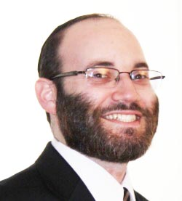

**I. ENSLAVING THE JEWS**

Were the Egyptians right in enslaving the Jews? The question seems outrageous at first. However, Pharaoh and the Egyptians fulfilled G-d’s prophecy to Avraham that his descendants would be enslaved in a foreign land (Gen. 15:13). Why, then, were the Egyptians punished? Ramban’s answer to this question reflects a broader opinion of his that is much-criticized but under-appreciated.

Rambam (Mishneh Torah, Hilchos Teshuvah 6:5) answers that while G-d’s plan includes people enslaving Jews, it does not specify who will serve this evil role. Every individual has the choice of doing good or bad and receiving appropriate recompense. The Egyptians chose to enslave the Jews rather than allowing another nation to do so. Therefore, they deserved punishment.

Ramban (Gen. 15:14) rejects this approach. The Egyptians fulfilled G-d’s prophecy, accomplishing His express will. Doing so is a mitzvah, not a sin. Rather, the Egyptians were punished for going beyond the prophecy, for overly oppressing the enslaved nation. Had they merely fulfilled the prophecy, they would presumably have been rewarded. However, because they went too far, they sinned and were punished.

The Ramban, at the end of his words, adds another explanation: The Egyptians had the wrong intention. They wanted to hurt the Jewish people, not to fulfill G-d’s will. Therefore, their actions were considered a sin rather than a mitzvah (see also Ra’avad’s gloss to Mishneh Torah, ad loc.).

**II. FULFILLING G-D’S WILL**

Ramban’s approach is surprising but intuitive and consistent. You can ask why people should feel obligated to instantiate a prophecy. Isn’t that G-d’s business? Indeed, many commentators ask this question on another passage where the Ramban adopts this approach. The answer to that question explains the Ramban’s view here, as well.

Why did Yosef refrain from immediately revealing his identity when his brothers appeared before him in Egypt? Ramban (Gen. 42:9) explains that Yosef wished to fulfill his dreams that his brothers and father would bow down to him. He deceived his brothers so they would bring Binyamin, and eventually their father, to bow down to him in Egypt. Why, many commentators ask, should Yosef feel obligated to ensure the dreams come true (e.g. Akeidas Yitzchak 29; Toras Moshe, ad loc.)?

The Vilna Gaon (Aderes Eliyahu, ad loc.) says simply that Yosef did not want to contradict G-d’s will. His concern was not specifically with serving as the defender of G-d’s words. Rather, he just wanted to be sure that he was on G-d’s side, doing what the Boss wanted. Fulfilling G-d’s will is not merely praiseworthy; it is a life goal to which all people must strive. Yosef refused to violate G-d’s will by attempting (presumably futilely) to circumvent the prophecies.

With this idea, we can better understand Ramban’s position (Gen. 49:10) that the Hasmoneans were punished for taking the kingship, which is reserved for the tribe of Yehudah and not priests like them. Why should they be punished when only a prophecy declares this, and not a command forbidding members of other tribes from taking the monarchy? As above, G-d’s will was revealed in a prophecy. Regardless of whether it was commanded, we must certainly strive to guide our will toward G-d’s. As the Mishnah (Avos 2:4) states, “Make your will like G-d’s will.”

Similarly, the Egyptians should have desired to fulfill G-d’s will, which the Torah tells us included enslaving the Jews. Had they not been overly zealous, their doing so would have been a mitzvah, an accomplishment that moved the divine plan forward.

**III. COMMANDMENTS & DIVINE WILL**

This position is so compelling that, to defend the Rambam, the Meshech Chochmah (Gen. 15:14) had to add another component. Granted, we must strive to fulfill G-d’s will. But we cannot make any such calculations when facing an explicit command to the contrary. The Meshech Chochmah posits that the Egyptians were forbidden to enslave the Jews. Therefore, their doing so, even in fulfillment of G-d’s will, was a punishable sin.

While the Meshech Chochmah does not cite his source, I believe his approach is consistent with that of Rav Chaim Volozhiner in Nefesh Ha-Chaim (3:21). Rav Chaim asked why, if according to the Talmud the Patriarchs fulfilled all the commandments, they occasionally violated them. For example, Ya’akov married two sisters, which the Torah forbids.

Many answers have been given to this question but Rav Chaim Volozhiner’s bears relevance to our discussion. He suggested that without explicit commands, the Patriarchs were free to do whatever they, with their deep insight, thought was spiritually best.

In my simplistic, non-kabbalistic terms: they could violate commandments to fulfill G-d’s will precisely because they were not commanded in them. Lacking that explicit imperative, they were permitted to look at G-d’s will more broadly defined. However, had they been commanded, they would have had to fulfill those obligations even at the expense of other indications of G-d’s will.

What law did the Egyptians violate by enslaving the Jews? The Meshech Chochmah suggests that the Egyptians violated one of the seven Noahide commandments, that of dinim (laws). He adds that they exhibited ingratitude because Yosef had saved the Egyptians from starvation. This is puzzling because it is entirely unclear how enslaving Jews violates the command of dinim and how ingratitude fits into that commandment. Rav Yehudah Cooperman, in his notes to the Meshech Chochmah, quotes the Ramban’s own words (Deut. 23:5) that Noahides are obligated to show gratitude.

However, this connection is still difficult within the Nefesh Ha-Chaim‘s framework. If the Egyptians faced an explicit command, they could not violate it in order to fulfill a prophecy. However, if they faced a vague command based on an intuitive sense of G-d’s will, then they should certainly incorporate a broader understanding of G-d’s will, including an explicit prophecy. Is the obligation to show gratitude really an explicit command such that we may not instead choose G-d’s will as expressed in a prophecy?

**IV. LAWS AND GRATITUDE**

Perhaps the Meshech Chochmah intended to tie this issue into another debate between the Rambam and Ramban. According to the Rambam (Mishneh Torah, Hilchos Melachim 9:14), Noahides are commanded to institute laws and judges (dinim). He is sufficiently vague to allow for an interpretation that Noahides are obligated to establish justice, which perhaps also includes legislating gratitude. However, Ramban (Gen. 34:13) disagrees with the Rambam. Ramban states that the commandment of dinim requires that Noahides establish courts that enforce the Torah’s civil laws (see Responsa Rema, no. 10).

Perhaps the Meshech Chochmah means that, according to the Rambam, Noahides are explicitly commanded within the framework of dinim to enforce gratitude. Therefore, the Egyptians were obligated to respect the Jewish economic salvation of Egypt, even in the face of a prophecy to the contrary. G-d’s apparent prophetic will cannot set aside His explicit legal will. However, the Ramban disagrees that gratitude is included within dinim. Therefore, broader concerns of G-d’s will can be weighed and fulfilling the prophecy of enslaving the Jews becomes a mitzvah.

We all want to be on the right side of history. Presumably, siding with G-d’s prophecies guarantees this. However, before we start calculating what G-d wants in a broader sense, we have to fulfill our local duties, obeying His will in that sense and, if need be, allowing others to accomplish His will. G-d will do what He wants but we may not always be able to play a role in that.

*Reprinted from the Pesach 5778 email of The ViEWS.*

**A Blast from the Recent Past (2015)**

**The Power of Good Women**

**By Rabbi Moshe Meir Weiss**



As I get ready once again to accept power of attorney to sell people chometz,, let me share with you the following memory. Several years ago when “facilitating the sale of chometz”, I had a remarkable discussion with one of mymispallelim.

While we were talking, I discovered that this would be his fourth opportunity to say Birchas HaChamah.  In 1925, he was twelve years old - and now as he gets ready to bless the sun the fourth time, he is in his 95thyear - may he live to greet the Moshiach.

As we were talking, I asked him if he remembers what the Great Depression was like.  He answered in the affirmative and related to me that life in Brownsville, Brooklyn, in the late 1920s and 1930s was very difficult indeed.  He remembered how his father was a carpenter and would not have regular work.

Rather, he would take his heavy toolbox on his shoulder early each morning and trek to a worksite where he would stand in line together with many other hopeful carpenters, hoping to have a chance to be chosen for a day’s work.  The foreman would select a few fortunate individuals and everyone else was sent home in disappointment.

This man said that he remembered, as a young man, the shining wisdom of his mother.  Afraid that his father might fall into a depression when he came home dispirited for not being selected to work, she would set out a nice table and offer reviving food to lift his spirits. He recalled that she would buy a box of rotten apples (for this was all that they could afford!) and cut away the bad parts and then wondrously manufacture apple strudel, apple cake, candied apples, and a host of other delicacies.

I told him that this wisdom of his virtuous mother, zichrona levracha, is taught to us in the Meam Loez on Parshas Ki Tzaittzay.  There, the Meam Loez informs us that the true sign of an Eishes Chayil, a Woman of Valor, is how she behaves when her husband is out of work.

This story got me thinking about our present situation a little less than a century later.  As we are reeling from an economic meltdown and suffering through a deep recession, many, many homes are today also facing such challenges.

While most of us do not have to buy rotten apples, the problems are of a different nature.  The worries about bank foreclosures on homes and cars, utilities being shut down, medical coverage being lost, and tuition not being met, causes the heads of households sleepless nights, stomach agitation, and all different types of stress related ailments.  It is here that I would like especially my women readership to absorb the sage words of the Meam Loez: that, in these times of tension, their status of Eishes Chayil is truly put to the test.

As I am writing this, I know that the almost instant reaction, especially of the American reader, is, “Wait, just one minute!  Why are you putting this on the women?  The men should equally be there for all of the stress that the women have because of today’s economy!”  So, let me explain.  As we remember the Pesach experience, the Medrash teaches, “She’b'zuchus noshim tzidkonios she’b'oso hador, nigalu - In the merit of the righteous women of that generation, we were saved.”

Besides the several extraordinary women that this refers to, such as Yocheved, Miriam, Tziporah, Bisya, and Elisheva, it is also a sweeping statement of praise about the millions of Jewish women in Egypt who, with great courage, encouraged their husbands to continue building Jewish families.  The Medrash tells us that the men became broken and crushed and weren’t interested in having more children.  They argued, Should we bring children into such a world to be crushed in the walls of Pitom and Ramses or to be faced with a horrible existence of tortuous slavery?

The women, however, with wise optimism, rejuvenated their husbands under the apple tress (which we commemorate at the Seder with the eating of charoses) and infused them with new hope to continue to build Klal Yisroel.  It was their valor that allowed for the increased Jewish population that Chazal teach us, enabled the years of servitude to end more quickly.

You might argue that the women in Mitzrayim had it easier than the men and that was why they were able to cope better.  But, in reality, it is just the opposite.  The Medrash tells us that part of Paroh’s diabolical treatment of the Jews was that he gave the men women’s work to do, and men’s work to the women.  So, the women were actually doing the hard labor formerly associated with men.  Yet, it didn’t break their spirits.  To the contrary, they persevered and took the initiative to rekindle the hope and spirit of their families.

This is a very important point that needs to be emphasized as we experience Pesach this year.  The women have to take the initiative in bolstering their husband’s confidence in seeking ways to be a calming influence in the home, a source of comfort after the harsh realities of a tough and oftentimes cruel workplace.

Our history teaches us, time and time again, good women throughout the ages, have the strength to do this.  While we do not have to buy rotten apples, women do have to figure out ways to cut down on household expenses, minimize use of credit cards, and set the tone for this behavior for the entire family.

In the merit of all the wonderful women out there, may we all be blessed with long life, good health, and everything wonderful.

*Reprinted from the March 10, 2015 website of Matzav.com*

**Passing Down Passover Traditions [in Oklahoma]**

**By** [**Carla Hinton**](http://newsok.com/more/carla-hinton)

[**0**](http://newsok.com/article/5588059/passing-down-passover-traditions#commentsModal)

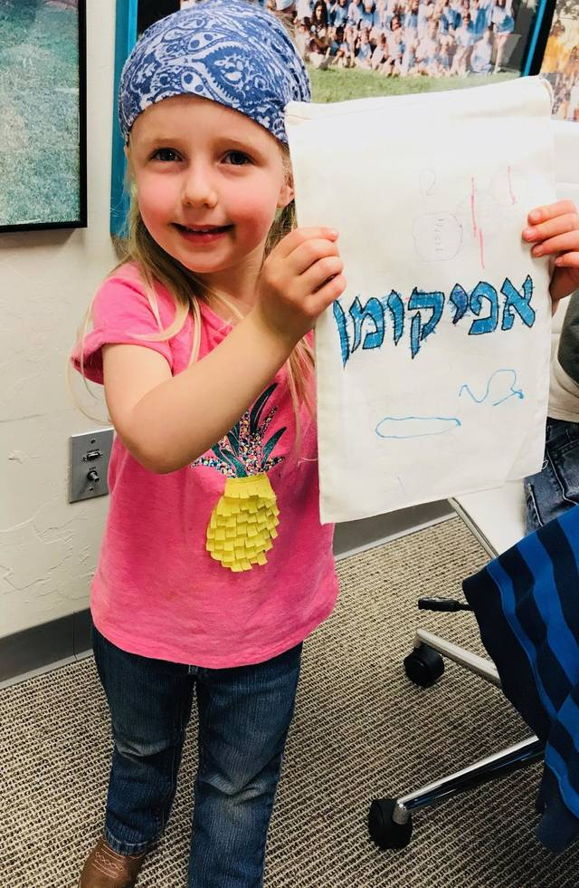

**Eliyah Houston, 3, shows her finished afikoman bag after a Passover related PJ Library session at the Jewish Federation of Greater Oklahoma City. The word "afikoman" is written in English and Hebrew on the bag. [Photo by Carla Hinton, The Oklahoman]**

Diane Barton-Lewis remembers when she was a young child embarking on the all-important search toward the end of the Passover Seder meal.

Young people participating in the meal are traditionally encouraged to look for the afikoman, a piece of matzoh taken from the Seder plate and hidden somewhere in the house. Once it's found, it is eaten as a dessert and in commemoration of the paschal sacrifice.

In Barton-Lewis' childhood home, children received a prize for finding the hidden matzah.

Those memories of yesteryear came flooding back as she watched her daughter Ally, 4, learn more about afikoman and its part in the Passover Seder ritual.

"This is like the kids' favorite part because they go look for it," she said. "I know in my family, there's always money associated with it."

Passover traditions were the topic of conversation at the Jewish Federation of Greater Oklahoma City's PJ Library session, which Barton-Lewis and her daughter attended.

Roberta Clark, the federation's executive director, said PJ Library is a national program of the Harold Grinspoon Foundation, and it is designed to bring Jewish families and children together around Jewish storytelling and Jewish values.

"It's a great opportunity to bring the Jewish community together for wonderful Jewish moments," Clark said.

She said the federation offers four to six sessions a year, typically tied to a holiday like Passover. The Jewish holiday begins at sundown Friday and ends at sundown April 7. It commemorates the Hebrews' exodus from slavery in Egypt as told in the Book of Exodus.

**'Part of it'**

During a recent PJ Library session, families gathered at the Jewish federation's office where Clark started things off with a colorful reading of "Company's Coming," a children's book about Passover.

After the story, Clark showed children and their parents how to make a matzah tray for Passover and a bag to store the afikoman. By tradition, it is typically stored in a bag or wrapped in a piece of cloth.

With nearby bowls of animal crackers to help keep their creative spark alive, Ally and Gabriel Friesen, 4, began working on their Passover projects, with Eliyah Houston, 3, and her brother Moshe Houston, 2, pursuing the same goal next to them.

Jennifer Friesen, Gabriel's mother, said she takes him to PJ Library sessions to make sure he has opportunities to learn about Jewish traditions that she didn't have.

"It's for him to be able to grow up and be a part of it and get to know all the traditional stuff that I missed out on," she said.

B.J. and Kim Johnston helped daughter Josephine, 1, who was interested in the marker colors but needed a little help with her craft projects.

The couple said Rabbi Vered Harris, the spiritual leader at their house of worship, Temple B'nai Israel, had encouraged them to allow their tot to participate in the sessions and activities like it.

"Rabbi gave the recommendation. She said even if you think she can't understand it, she can absorb it by being around it," Kim Johnston said.

Clark said Jewish leaders always have wanted children to be engaged with the Seder meal, and thus the afikoman was introduced. The Seder is a sacred, ceremonial meal, which includes special foods, prayers and rituals that help to tell the story of the Israelites' redemption from Egypt.

Matzoh is a Passover staple because the flat unleavened bread (resembling a cracker) is an integral part of the Passover story. There was no time for the Hebrew slaves' dough to rise before they fled Egypt and Pharoah, so their resulting unleavened bread, matzoh, is often called the "bread of affliction" or the "bread of haste."

Clark said the afikoman is the middle piece of matzoh taken from three matzoh squares at the Seder meal.

The children at the recent PJ Library session used markers to decorate their bag for the afikoman.

"Bubbe (grandmother) is going to like it!" Clark told Ally as the young girl and Gabriel both expressed great pride in their finished bag.

Family members said they already had participated in several activities designed to share Passover on a child-friendly level. Barton-Lewis said Alley had made a Seder plate at a Shabbat Tot activity at Temple B'nai Israel.

And Friesen said Gabriel got a chance to make matzoh at Chabad Jewish Center for Life and Learning.

Nechoma Goldman, Chabad's program director, said the matzoh-making session at Chabad's Hebrew School was in keeping with the organization's mission to teach Passover traditions and other aspects of Jewish life and culture to young people.

"It's really our history. It's who we are so it's important to teach it to our children. They are the next generation," she said.

*Reprinted from the March 24, 2018 website of The Oklahoman (Oklahoma City, Oklahoma)*

**Wine Only or is**

**Grape Juice O.K.?**

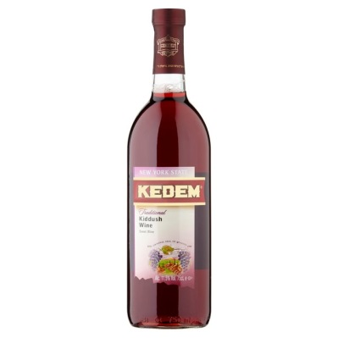

**QUESTION:** Must I use wine for the four cups [on the Pesach Seder], or may I use grape juice instead?

**ANSWER:** There are two schools of thought among the Poskim. R’ Moshe Feinstein (Hagaddah Kol Dodi 3:4) maintains that since Chazal instituted the drinking of four cups of wine to feel a sense of freedom, grape juice should not be drunk.

Although it has the *halachic* status of wine, it is not an alcoholic beverage, and one only feels a sense of freedom when drinking an alcoholic beverage. (If there is the possibility that the person will be endangered by drinking the wine, grape juice may be used.)

This was also the opinion of R’ Eliyashiv (Shvus Yitzchak, Peasch 10:2) and R’ Ben Tzion Abba Shaul (Ohr Letzion III, 15:4).

However, the Chazon Ish (Hilchos Chag B’Chag, Chapter 19: fn. 24), the Brisker Rav and the Tchebiner Rav (Teshuvos VeHanhagos II, 243) held that it is unnecessary to drink wine, and grape juice is acceptable. Indeed, these great Sages actually drank grape juice at the *seder* (ibid.).

Rav Yosef Dov Soloveitchik as well drank grape juice for the last three cups. However, he insisted on drinking wine for the first cup (*Kiddush*) to satisfy the opinion of Rambam that one may not use cooked wine for *Kiddush*. Since grape juice is always cooked, he would only  use non-*mevushal* wine for *Kiddush*. R’ Shlomo Zalman Auerbach (Halichos Shlomo, Pesach 9:11) explained that since grape juice has the *halachic* status of wine, one experiences freedom when drinking grape juice even though it is non-alcoholic.

*Reprinted from the March 29, 2019 Halacha Yomis email of OU Kosher.*

**Perhaps the Largest Passover/Pesach Seder**

**In the World - in Nepal**



Thousands of young Israelis often take a year to travel the world after completing their military service, and many end up in Nepal. This Seder in Kathmandu last year may have been the largest in the world, according to its organizer, Chabad House of Kathmandu under the direction of co-directors Rabbi Chezky and Rabbanit Chani Lifshitz. Rabbanit Lifshitz is seen fourth from the left as she encourages other Jewish women to light the Yom Tov tea lights at the Nepalese Seder.